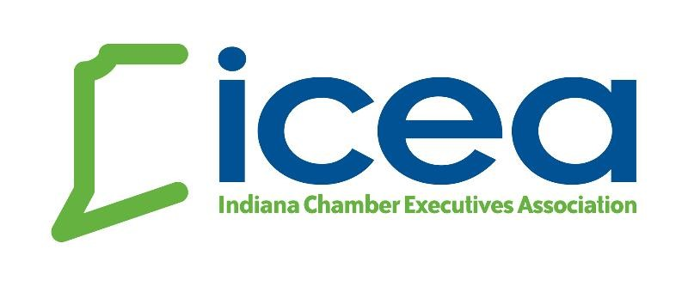
Succession Planning – Board Dialogue Questions
1. If the contract manager (President) is suddenly unable to serve, or retires, has the Board identified candidates for the job?
* If the answer is yes, is that talent prepared? Do they have the required leadership style, financial knowledge, contacts and necessary experience to take charge of ICEA and continue to provide members and funders with uninterrupted services?
- If the answer is no, what is the Board’s plan for hiring another president who understands how to lead your organization and continue to provide uninterrupted service to the members and funders?
- Does everyone within the organization know who will be the acting president until the board can meet and appoint someone officially?
2. Would your organization be able to sustain a decline in income or fundraising activities without the contract manager? Is the contract manager the primary fundraiser? Do board members work with the contract manager to maintain relationships with funders?
3. Do funders trust that the organization can succeed without the current contract manager?
4. Does the board have the right mix of talent to effectively hire a new leader for your organization? How committed and supportive is the board to the success of the president?
5. Will the organization lose institutional knowledge and contacts if your president were to suddenly leave?
6. Is the president’s current level of responsibility realistic, or has the president, in good faith, taken on too much responsibility at the expense of overall development? What skills need to be replicated in the new president?
7. Does your current president understand and possess skills and expertise necessary to lead your organization in today’s resource constrained-world?
8. Are there other positions besides the president that would leave the organization vulnerable should they depart? If so, what plans are in place to address their departure?
9. What information would board members expect to have included in the database upon transition?
10. Would board members expect a period of mentoring the new president?
11. With existing budget parameters, what feasible options are best to consider when the time to transition contract management of ICEA becomes a true issue for the Board?

