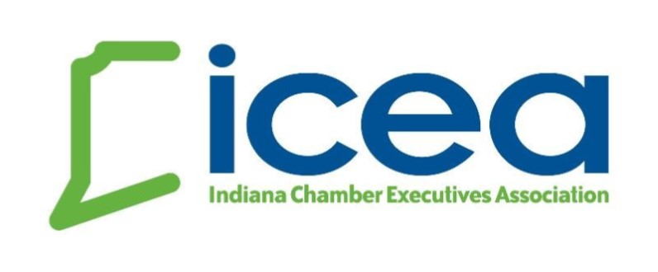
Indiana Chamber Executives Association Scholarship Application

This scholarship application is for attendance at the 2021 ICEA Annual Conference.

Deadline to Apply: April 20, 2021

Eligibility
All full-time or part-time paid chief execs or staff members who are ICEA members are eligible for scholarship assistance.

ICEA Scholarship Application
Name:
# of years in present position: # of years in chamber work:
Total budget of organization: $
Staff development budget for 2021: $

Where do you need financial assistance?
⃝ Conference Registration Fee ($199 for ICEA member rate for full conference; $179 for add’l. staff from the same chamber.)
⃝ Hotel Overnight ($159 per night - Embassy rooms are suite size and scholarship recipients may be paired with a roommate)
⃝ Both Conference Registration and Hotel Overnight Expenses

Please return this completed form to shelli@iceaonline.com no later than 4/20

