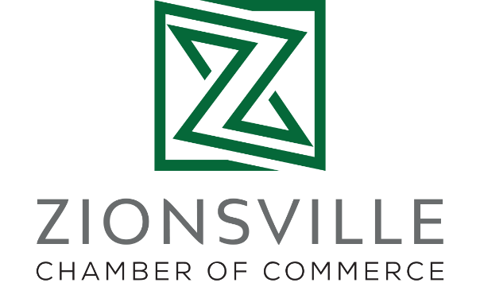
Microgroups
The Microgroups initiative began as a way to more effectively engage members and address needs among businesses who have a common set of interests. Because businesses may experience challenges differently based on the type of business they are and/or where they are located, Microgroups allow us, as a Chamber, to be more responsive and speak to member needs with greater intent.
Though these currently do not encompass all our members, in 2021, businesses were invited into categories as either a primary practice group or a “neighborhood.” Microgroups launched with five select practice groups (Restaurants, Senior Living Services, Non-Profit, Home-Based Businesses and Real Estate) as well as three retail neighborhoods (Main Street, Mid-Town and the Michigan Road Corridor).
Chamber staff, along with volunteer Microgroup leaders, have hosted both in-person and virtual meetings for Microgroup participants. These are currently scheduled once a quarter and may include speakers on topics relevant to that specific industry or area of town. Gatherings allow opportunity to network, discuss challenges, share strategies and celebrate successes. Rather than existing as potential competitors, this structure leads to peer mentoring and collaboration, building connection and the formation of a network of local colleagues ready to assist and support one another — which in turn also helps membership retention.
Additionally, we have learned of members connecting and then joining the boards of other member’s organizations as a direct result of participation in the Microgroups!
These groups consistently demonstrate creativity and regularly offer ideas for the Chamber to create more meaningful programs that better serve our membership as a whole. As a few examples, the Main Street Microgroup proposed solutions to downtown parking challenges. The Home-Based Businesses Microgroup came together to host a unique Facebook Live marketing opportunity called Holiday Shopping Edition that encouraged local online shopping and featured gift ideas from this segment of members who don’t have storefronts. And the Mid-Town retail group expanded the area’s traditional holiday festivities by planning a Grinchmas event to encourage shopping in Zionsville’s mid-town district.
The year started with these select categories and we will continue to adapt and expand as needs and interest allows. With the membership growing and diversifying, this structure facilitates built-in sounding boards as well as the flexibility to try new ideas with smaller segments of the membership. In turn, we look forward to the continued influx of ideas and meaningful engagement from members participating in these Microgroups.

