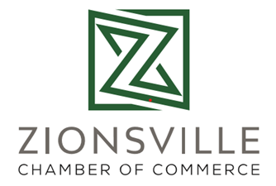
Micro Economic Development

In 2020 we decided it was time to really focus on the core of our membership: small businesses. 83.4% of our businesses are small, with the bulk of our membership being companies with under five employees. Our town as a tourism draw is really as a result of our small and micro businesses. So, we decided to better embrace the businesses that are on the cusp of growth in a new way. We created a membership category for home based businesses.
It didn’t take long for the home based businesses to find out that they finally had a ‘place at the table’. We offer a Microgroup, a distillation of our membership into practice groups or neighborhoods where businesses operate, just for Home Based Business Members. This meeting gives them a chance to communicate with other HBB Members and share challenges that stem from running a business out of a home office.
We called our new outreach “Micro Economic Development”. Instead of thinking big we started thinking small. We wanted to have a pipeline of businesses that were ready to take their next step if a storefront opened on our historic Main Street and Midtown shopping districts. We offered partnerships with our Main Street Members, pairing businesses up for Black Friday weekend, where HBB members could sell their items from within a Main Street Member’s store. It was a huge success and we look to see it replicated again soon. We also offer HBB members the same opportunity to sell on our ShopZionsvilleChamber.com page, just like our brick and mortar retailers. HBB members may also attend networking and educational events, and often do in greater numbers due to the increased challenges associated with networking from home.
Since January 2020 this membership category has 45 new members and is the second largest segment of our membership by number of members, representing 8% of our membership in one year. Our highest year of membership growth prior to 2020 was 43 members in a full year, a threshold which we hit in May of 2020 and April of 2021! Last year we gained 120 new members (a 30% membership gain in one year!) and we are on track to meet and surpass this mark in 2021. Our home based business category has been a significant contributor to our growth and success as we innovated for our Members in 2020 and beyond.

