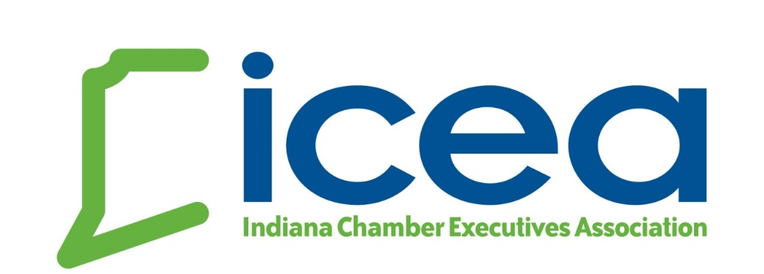
Executive of the Year Award Nomination
Recognizing the quality of chamber of commerce executives in Indiana, the statewide chamber professional association initiated an annual award for the most outstanding executive in our field. The ICEA Executive of the Year Award will identify the most effective chamber professional who has made a significant difference in a local chamber.
This award recognizes the long-term professional career achievements of the recipient. Criteria to be evaluated include 1.) professional experience; 2.) training & education; 3.) ethical conduct in dealing with peers; 4.) professionalism; 5.) leadership; and 6.) desire to advance the profession of chamber management. This award will be presented at the Annual Winter Conference & Awards Luncheon.
The Chamber Executive of the Year award recipient will receive a plaque, statewide peer recognition and media recognition with announcement letters sent to local media & Board leadership.
HOW TO NOMINATE
Submit a brief essay (up to three pages maximum) describing why the nominee is deserving of this award. Nomination may include recommendations, news clips, and other documentation of a job well done. Please consider nominating a chamber executive for this prestigious award. A selection committee comprised of chamber professionals outside of Indiana will review all nominations and make a recommendation to the Board for approval.
SELECTION CRITERIA
1.) At least three years as the lead executive at the chamber
2.) Demonstration of long-term exemplary performance and leadership with his / her local chamber and extraordinary contributions to the profession of chamber management
3.) Demonstrated ability to positively lead change at the local chamber level, including specific examples of vision, leadership and management.

Please e-mail nominations to info@iceaonline.com prior to June 10, 2020.

