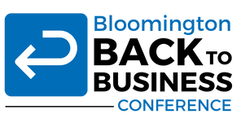
Excellence in Innovation Nomination

May 6-26, 2020, the Greater Bloomington Chamber of Commerce held a virtual conference free for the entire community. Focused on topics around the reopening in the midst of the pandemic, from physical safety to legal issues for employers, the conference reached 496 attendees from different businesses and organizations over the 24 sessions.
Conference presenters included local experts, including Chamber members, community leaders, health professionals, economic development experts, and financial industry experts.
More info, as well as recordings made available to the community for reference, can be found here: https://www.chamberbloomington.org/backtobusiness-conference.html

